EXAMPLE PROGRAM
Objective: To implement and verify a program on a Mano-based Basic Computer to perform memory-to-memory addition
Hex Code: 2004 1005 3006 7001 0450 1230 0000
Theory:
The Program Counter increments its value from the starting index every sequence cycle. Each computer cycle performs an instruction stored in the memory pointed by PC. The following program has 4 operation which effectively add two numbers from memory, store the result in adjacent memory and halts the computer.
PC | Instruction | Interpretation | RTL
000 | 2004 | LDA 004 | AC M[004]
001 | 1005 | ADD 005 | AC AC + M[005]
002 | 3006 | STA 006 | M[006] AC
003 | 7001 | HLT | S 0

Procedure:
1. Open the Circuit on Logisim
2. Right Click on the Memory and click “Edit Contents” (Fig 1). This opens the hex editor through which the memory can be manually edited (Fig 2). Right Click on the first memory and paste the hex code provided above (Fig 3)
3. Close the Hex Editor.
4. Scroll down to the debugging section of the circuit (Fig 4).
5. Ensure all registers initially have no information stored in them.
6. To begin simulation, press Ctrl + K to begin the simulation. Depending on the clock frequency set in the simulation Tab on the top left of the screen, the simulation may take some time or occur instantaneously.
7. Restarting the computer involves stopping the clock (Ctrl + K), resetting the circuit (Ctrl + R) and pasting the hex code as instructed in Step 2.
Observations:
Data Stored at 004 = 0450
Data Stored at 005 = 1230
Sum of the numbers = 0450 + 1230 = 1680
Data Stored at 006 = 1680
Result:
The design successfully executed memory-reference instructions (LDA, ADD, STA) and register-reference instructions (HLT) as evidenced by the correct hex output in Logisim.

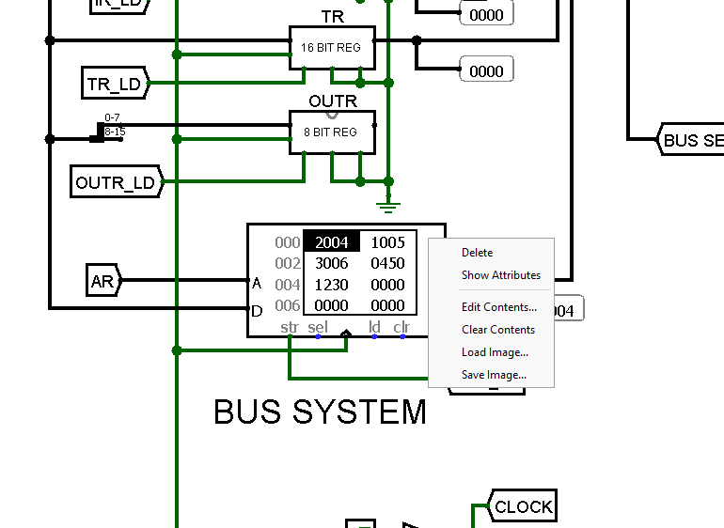 | 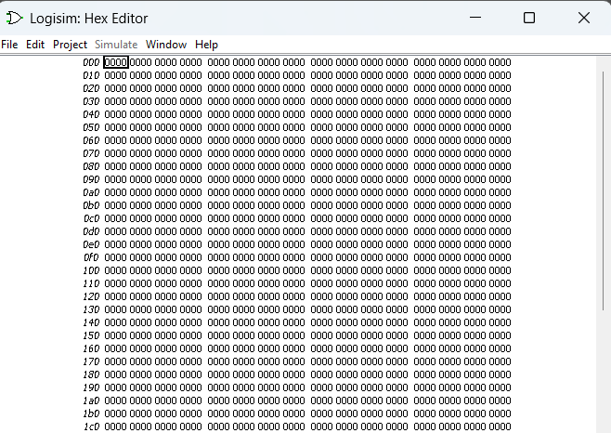
Fig 1: Open Memory Contents | Fig 2: Hex Code Editor
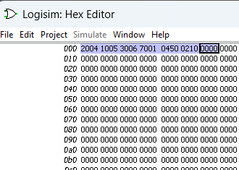 | 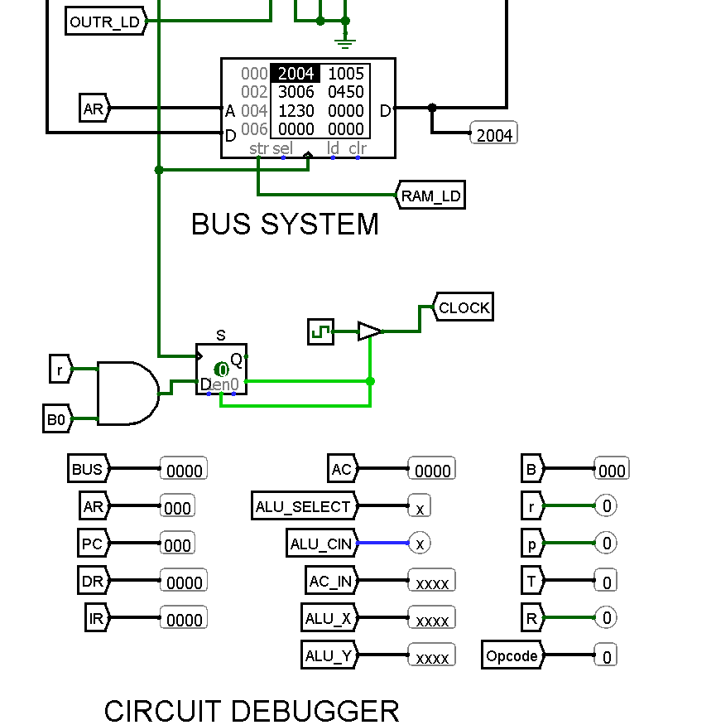
Fig 3: Paste the Program | Fig 4: Circuit Debugger

